# Project Title: Recruitment analytics and tracking

## Team Name: Onions

## Team Members: Harish Shanmugam, Ashok Ram

## Logo: C:\Users\hshanmugam\Desktop\Noun_Project_20Icon_10px_grid-06-2-512.png

## Description:

This project will help the recruiters to manage the resumes (or CV) in the common location and analyze candidate based on the resume and allow to manage the Interviews and feedbacks.

## Modules:

The following are the list of modules

1. Crawling Resumes
2. Indexing the Resumes
3. Analysis and categories the resumes
4. UI Module for searching the resumes
5. Interview Process Management

### Crawling Resumes:

This module will crawl the resumes from the mail server using the google mail API connector. The mail servers can be either google mail server or outlook mail server. The google mail API connector will listen to the google mail servers, and whenever the new mail receives it will automatically download the complete mail and preserve at server filesystem.

### Indexing the Resumes:

After preserving the mails at filesystem, this will module will index the resume at Solr Index with basic categorization. Where Solr will act as the indexer.

### Analysis and Categories the resumes:

Once the resumes are indexed at solr, this module will deep analyze and categories the resumes based on the skill set expertise, qualification, preferences, experience and role. The final categorizations are preserved at normal RDBMS (MS SQL).

### UI Module:

This module will allow the recruitment team members to search/filter the required resumes from the common resume warehouse. The filters will help the recruiters easy to search the right candidate based

### Interview process management:

This module will help the recruiters to collect the score of the candidate and feedback of interviewer. Then based on the decision of the recruiters, it will allow the candidate to next round or reject the candidate. All the rejected candidates’ details need to store and blacklist the candidate for the particular period of time according to the companies’ regulation.

## Technologies:

Java 8, Tomcat 8, Maven 3, MS SQL Server, Solr Index, etc

## Architecture Diagram:

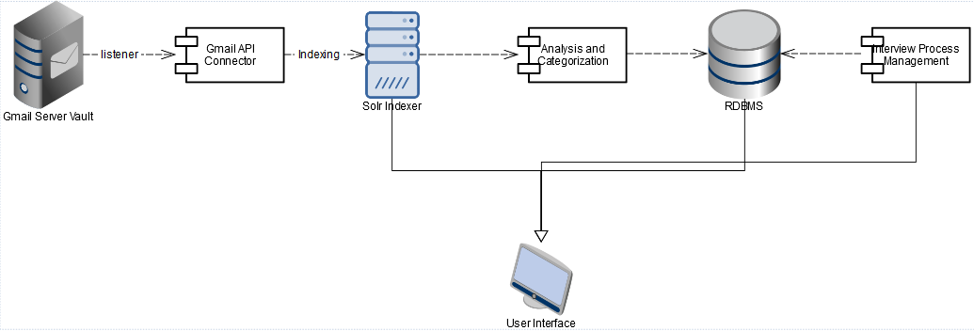

## Conclusion:

TODO

Design document(class diagram,uml diagram), Unit test cases

Presentation